### **Rare Candy Simulation Document**

#### **Overview**

This Java program simulates the odds of all rare candy cards ending up in the prize pile. As long as you have a playable hand (at least one pokemon card in hand).

#### **Key Components**

* **Card.java** – Represents a single card in the deck (either "rare candy", "pokemon", or "energy").
* **RareCandy.java** – Runs the simulation with the following steps:
  + Shuffle the deck.
  + Draw cards into a hand and check for Pokémon cards.
  + Check if rare candy cards are found in the prize pile.
  + Track and adjust the number of rare candy cards in the deck.
* **RareCandyTester.java** – Runs the simulation and displays the results.

#### **Simulation Process**

1. A deck of 60 cards is created: 1 rare candy, 20 Pokémon cards, and 39 energy cards.
2. The deck is shuffled, and 7 cards are drawn as the hand.
3. If a Pokémon card is in the hand, the next 6 cards (prize pile) are checked for rare candy cards.
4. The number of rare candy cards in the prize pile is tracked over 10,000 trials.
5. After each set of trials, if the number of rare candy cards is less than the limit, another rare candy is added to the deck.
6. The odds of finding all rare candies in the prize pile are calculated and displayed.

#### **Results**

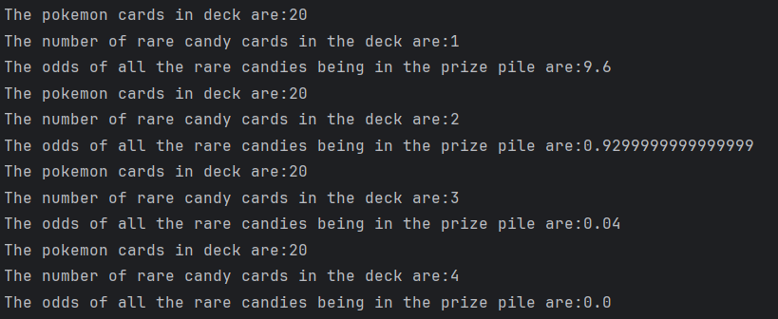

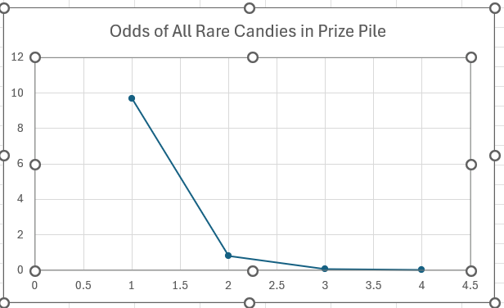

#### **Conclusion**

This simulation demonstrates how the odds of finding all of the rare candy cards in the deck in the prize pile change based on the number of rare candy cards in the deck.